Hello everyone. I'm Diane. Thank you very much for coming to this lecture session.
Today’s meeting includes four points:
1.YGone reward information:
2. Promotion to senior positions
3. Question time: If you have any questions, you can send them to the group. I, Jessica and the administrator will answer all your questions and hold a lottery draw at the meeting!
First of all, our new members, please remember: YGone is a big family. Unity, self-confidence, improving one's own business skills, gratitude and sharing are the core ideas of all our YGone employees! Communicate with each other, learn from each other, and share your own team building experience. This is what each of our members needs to do. I hope every YGone employee can be happy!
YGone is an advertising application developed by YGone Group LTD. YGone mainly operates advertising videos for global luxury brands. It is a video advertising and promotion company that cooperates with many luxury brands such as Adidas, Louis Vuitton, Hermès, Nike, Chanel, Cartier, and Rolex. Our philosophy is to create an advertising platform that combines low cost and ease of use, creating a good investment environment for customers and truly enjoying it. Really enjoy working on the Internet!
The YGone work system is an employee position hierarchy. The amount of publicity work that different job levels can accept and the salary for completing the work are different. The higher the job level, the more videos you can watch and the more you get paid.

For employees who join YGone, they only need to pay the corresponding job deposit to work online. After the job deposit for the corresponding position expires, you can choose to resign, return the job deposit, or continue working. After leaving the corresponding position, you only need to pay the deposit again to continue working at YGone.

Regular employees: need to pay a work deposit of 20USD, have 4 work tasks per day, each work task is 0.2USD, earn 0.8USD salary per day, and earn 24USD per month. After working for 60 days, you can choose to return the work deposit or continue working.

Intermediate employees: need to pay a work deposit of 100USD, 8 work tasks per day, 0.5USD per task, earn 4USD per day, and 120USD per month. After working for 90 days, you can choose to return the work deposit or continue working.

Senior employees: need to pay a work deposit of 350USD, 10 work tasks per day, each work task is 1.4USD, earn 14USD per day, and earn 420USD per month. After working for 120 days, you can choose to return the work deposit or continue working.
Invitation rewards
YGone’s invitation rewards:
If we use our own invitation code to invite regular employees to join YGone:
Every time you invite a regular employee (20USD) to join YGone, you will get 1 USD and 1 lucky point reward.
Every time you invite a mid-level employee (100USD) to join YGone, you will receive a reward of 5 USD and 2 lucky points.
For every senior employee you invite to join YGone (350USD), you will receive a reward of $17.50 and 3 lucky points.
All employees who join YGone can enjoy invitation rewards, and every employee can earn additional income through invitations.
Agency commission
Similarly, through invitations we can also earn agency commissions
Let me explain to you what agency commission is:
We invite people to join our team. As long as your subordinates complete their work on time every day, we can earn agency commissions. The agency commissions can be divided into three parts ABC
First we need to understand the team structure. What are your A-level team members, what are your B-level team members, and what are your C-level team members?

We all know that as a member of YGone, everyone has their own invitation link. This is the key for us to obtain invitation rewards and agency commissions.

First, after finding your own invitation link, we can share it. After we share successfully, your friend uses your invitation link to complete the creation of a YGone work account, then your friend will be your A-level team member.

When the A-level team members you invite join YGone, they will also have exclusive invitation links. When your A-level team members successfully share the invitation link, the employees who join YGone will become your B-level team members.

When your B-level team members join YGone, employees who register through the B-level team member invitation link will become your C-level team members.

This is an explanation of the three parts of ABC of our team structure. Every employee who also joins YGone can become the founder of the team. As the founder of the team, we also enjoy agency team commissions, and we can enjoy A-level team members 5 % work commission, B-level team members have a 3% work commission, and C-level team members have a 2% work commission.

If there is one employee in your A-level team who is a mid-level employee, then as the leader of the team, we can enjoy the agency commission of 0.2USD per day for A-level team members.
If there is one employee in your B-level team who is a mid-level employee, then as the leader of the team, we can enjoy the agency commission of 0.12USD per day for B-level team members.
If there is one employee in your C-level team who is a mid-level employee, then as the leader of the team, we can enjoy the agency commission of 0.08USD per day for C-level team members.

When there is only one member of our ABC team, we can earn an agency commission of 0.4USD per day. If our ABC team has many members, we can earn 40USD agency commission every day with 10 people. What if there are 100 people and 1,000 people?

The agency commission is automatically issued. As long as your subordinate completes the work, you can get his agency commission as well as invitation rewards! Agency commissions and invitation rewards are available to all our YGone employees, and every employee can become a team leader.

As long as your goals are big enough, each of us can become a leader in life! In addition to invitation rewards and agency commissions, you can now earn lucky points by inviting others to join. You can get 1 lucky point by inviting regular employees to join YGone, and you can get 2 lucky points by inviting mid-level employees. Lucky points can be used to play Lucky Roulette, and we can draw bonuses and Apple 15s on the roulette wheel, which allows us to have fun after work. The Lucky Roulette feels great to me.

What I talked about above is YGone’s invitation rewards and agency commissions. Next, let me explain to you what YGone Fund is:
YGone Fund and YGone Fund financial products:
YGone Fund was established at the same time as YGone. Employees who join YGone can deposit funds from their work accounts into YGone Fund. YGone Fund can earn you 0.5% income every day, and the income will be distributed to your YGone Fund account at 23:00 EST every day. We can deposit the income earned from watching videos into YGone Fund, which can steadily help us generate 0.5% every day. Similarly, YGone Fund also has YGone Fund financial products:

Currently, there are four YGone Fund financial products:
1. YGone Fund 7-day 20USD financial product: It can generate 1% income of 0.2USD for you every day. It can generate 1.4USD of income after 7 days. You can get back the principal and interest after 7 days of investment. The total income is 21.4USD.
2. YGone Fund 7-day 100USD financial product: It can generate 1% income for you every day, 1USD. After 7 days, it can generate 7USD income. You can get back the principal and interest after 7 days of investment. The total income is 107USD.
3. YGone Fund 30-day 20USD financial product: It can generate 1.5% income of 0.3USD for you every day. It can generate 9USD of income after 30 days. You can get back the principal and interest after investing for 30 days. The total income is 29USD.
4. YGone Fund 30-day 100USD financial product: It can generate 1.5% income for you every day, 1.5USD. After 30 days, it can generate 45USD income. You can get back the principal and interest after investing for 30 days. The total income is 145USD.
This is the introduction to YGone Fund and YGoneFund financial products. Funds invested in YGone Fund can be withdrawn to your TRC20 wallet account from Monday to Friday. YGone Fund financial products can be purchased once a month. After the investment is completed that month, each financial product of YGone Fund will generate investment shares in the second month!
Senior positions:
YGone will fully open senior positions at 00:00 EST on November 6, 2023, at which time all personnel can be promoted to senior employees.
Advantages of promotion to senior staff:
Become a senior employee: You need to pay a work deposit of 350USD, and you can complete 10 work tasks every day. You can earn 1.4USD per work task, 14USD per day, and 420USD per month.
If you invite your friends to become senior employees, then you can get an invitation reward of 17.5USD and 3 lucky points. If your friend activates formal employee, mid-level employee, and senior employee at the same time, you can get a total of 23.5USD invitation reward and 6 lucky points.
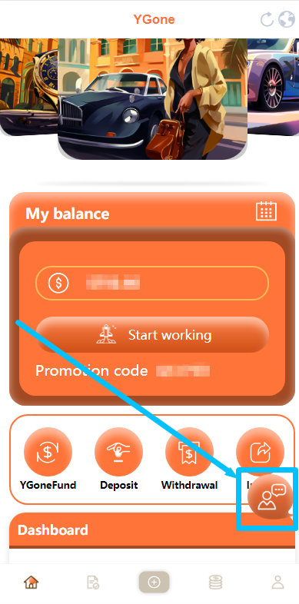

After you log in to your YGone work account, you can click here to contact me and Jessica to help you solve deposit or any other problems!
Our commitment is: help every YGone employee solve all problems!
I hope everyone can work happily at YGone and earn more money to make their lives better!

The above are the benefits that YGone employees can currently enjoy, which are crucial to our development. As we all know, the Internet era has arrived. In the future, Internet projects will definitely be the most profitable projects. Everyone has the potential to become a leader of the times, and YGone can provide each of us with stable, long-term work and income.

